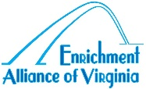
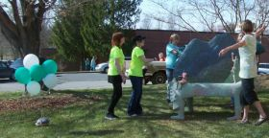
MONUMENTAL COLLABORTIONS
APPLICATION
Name of Organization: |  |  |  | Contact Person:
Phone Numbers: |  |  |  | e-mail:
Why are you interested in participating in Monumental Collaborations? (Please continue on back if needed).
Are key figures in your program (e.g. principals, executive directors, custodians, teachers) supportive of this project?
There will need to be one person in your program who is able to be our point of contact with your program. This person will need to assist in recruiting students, contacting our staff about schedule changes, and facilitating communications between our staff and your program. Is there someone in your program who is committed to doing that?
What financial and/or other resources can you bring to this project? (An example of financial sources would be PTO funding. An example of other resources would be student service organizations).
Will this program provide opportunities to include children and youth among any of these populations:
English Language Learners?

Individuals with disabilities?

Low Income?

Rural?

Other communities with limited access to the arts?

Continued on back.
Where will the Monument or Mural be located?
Is there an indoors space where we can work during inclement weather?
Will we have access to a storage space? |  |  | Will we have access to running water?
This project will take place during (check all that apply):
Regular School Hours |  | After School |  |  | Week-ends |  | Other, explain
When are you hoping to begin this project?
How many hours a week will be available for hands-on work on this project?
Please mention any special opportunities your organization have that will enhance the project. As examples: after school programs, enrichment periods, or staff members with a passion for the visual arts.
Feel free to use the remaining space for any additional information you would like to share.
www.enrichmentalliance.org staff@enrichmentalliance.org 434-295-1002
PO Box 1423 Charlottesville Va. 22902

