Camping for All, The Enrichment Alliance of Virginia, and Charlottesville Parks and Recreation Therapeutic Recreation will sponsor:

Let’s All Play
A training on inclusion for recreational programs.

Tuesday, May 16th.

8:30 A.M. – 12:30 P.M.
Presented by Aron Hall of The National Inclusion Project.
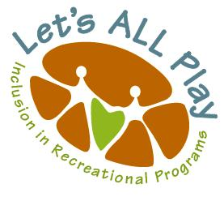
As described by the National Inclusion Project: “This training is designed to train front line staff, leadership staff, executive boards, cross-program staff and/or representatives from multiple communities’ programs. Your staff will be equipped to understand why inclusion is important, how to serve families effectively, how to assist children in creating friendships, how to achieve positive behaviors, and how to create accessible activities.” www.inclusionproject.org
Early Bird Registration April 1. $15-$20.
General Registration May 1. $20 -$25.
Register Here.
Two hours free parking.
For more information:

Enrichment Alliance of Virginia
PO Box 1423
Charlottesville, Va. 22902
enrichmentalliance.org

staff@enrichmentalliance.org
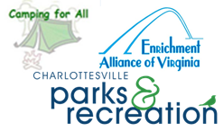
434-295-1002

