Workshops Offered by The Enrichment Alliance of Virginia
Opening Dialogue with Families. From your promotional materials to conversations at pick-up, you are engaged in dialogue with families. In this workshop we will explore the messages about inclusion providers send and receive through written materials such as webpages and applications, and through the conversations with families. The goal of this workshop is to help providers develop a team relationship with parents in order to improve the exchange of information needed to help children with disabilities have successful camp experiences.
Recommended time allotment: 1 ½ hours.
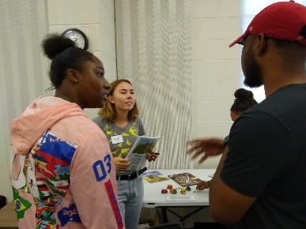
Creating a Supportive Environment. This workshop provides an overview of commonly used strategies to support children with autism, ADHD, and other neurological challenges. In this workshop, we will address some of the common issues that occur in out-of-school-time programs, such as standing in line, handling transitions, having positive experiences with craft and sports activities, and coping with sensory sensitivity.
Recommended time allotment: 4 hours. May be broken into two 2 hour sections.
Ew! Glue! What’s so scary about a bottle of glue? What can possibly be challenging about tearing a piece of cellophane tape off its roller? For some children with sensory challenges, a bottle of glue might as well be a vat of acid. For some children with fine motor challenges, tearing off a piece of tape might seem like brain surgery. With a few simple accommodations these and other camp and after school activities can be engaging and rewarding for every child in your program.
Recommended time allotment:1 and ½ hours.
Welcoming Children on the Autism Spectrum in Your Enrichment Program. This interactive workshop begins with looking at some characteristics common among children on the autism spectrum, then moves into simple ways programs can support children with autism in their programs.
Recommended time allotment: 3-4 hours. May be split over two sessions.
Community Workshops: We also host occasional community workshops, usually with outside presenters chosen for their expertise in a particular area affecting afterschool and/or inclusion. Topics currently under consideration include: Easy to Use Enrichment Activities, Inclusion of English Language Learners, Inclusion of Children with Disabilities, Inclusion of Children Impacted by Trauma, Recognizing and Responding to Abuse and Neglect, and Safe Support in a Behavioral Crisis. Please sign-up for our mailing list on our website to receive information about these trainings.
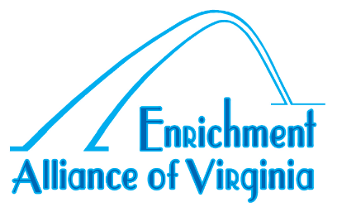
Pricing:
Staff workshops are $100 to $300 depending on the length of the workshop.
Consult services are $30.00 an hour after an initial, complementary meeting.
Community workshops prices vary.
staff@enrichmentalliance.org
www.enrichmentalliance.org

