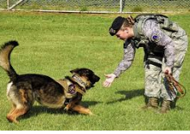  COME |  | JUMP |  | 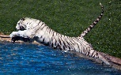  LUNGE
ONE |  | 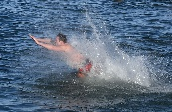  PLUNGE |  | RUN
SOME |  | 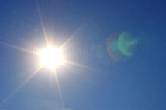  SUN |  | THUMP
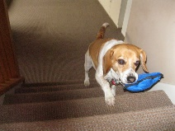  BRING |  | CLEAN |  | 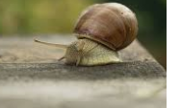  CREEP
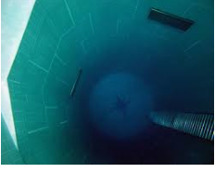  DEEP |  | 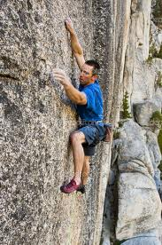  CLING |  | 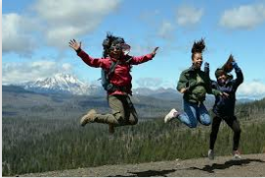  FREE
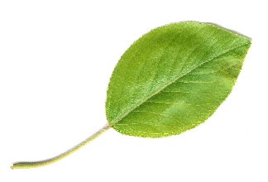  LEAF |  | LEAP |  | SEE
SING |  | SWEET |  | 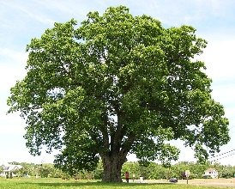  TREE
ARE |  | 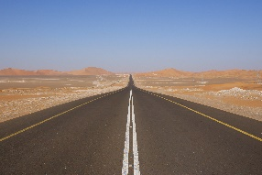  FAR |  | FOR
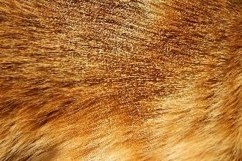  FUR |  | MORE |  | ROAR
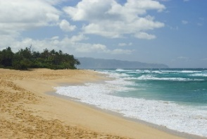  SHORE |  | 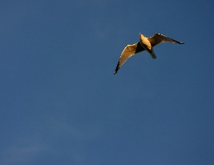  SOAR |  | SURE
BEGIN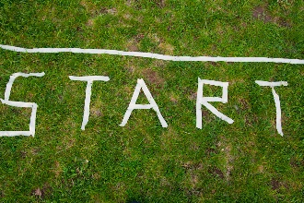 |  | 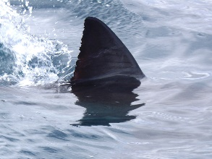  FIN |  | 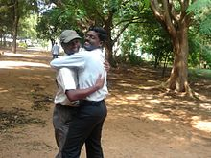  FRIEND
LIFT |  | 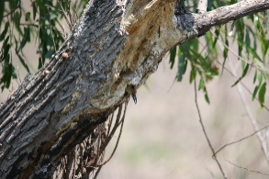  LIMB |  | RIM
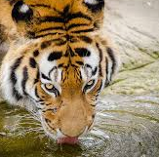  SIP |  | 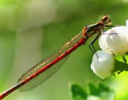  SLENDER |  | 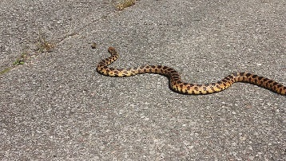  SLITHER
SPIN |  | 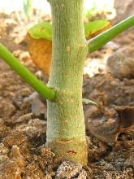  STEM |  | 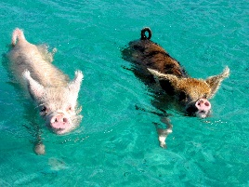  SWIM
AND |  | CAN |  | BEGAN
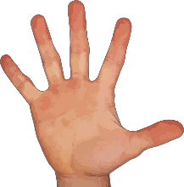  HAND |  | 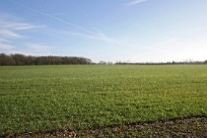  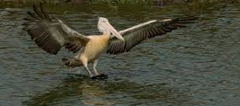  LAND |  | RAN
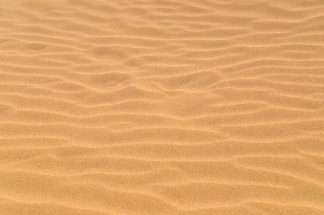  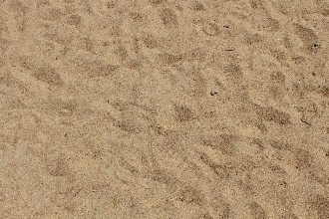  SAND |  | 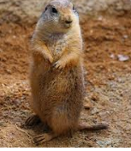  STAND |  | 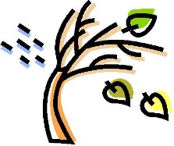  WIND
DAY |  | GAZE |  | FACE
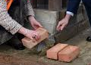  LAY |  | MAKE |  | PLACE
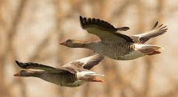  SAIL |  | 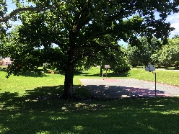  SHADE |  | 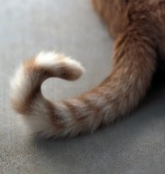  TAIL
All images are CreativeCommons unless otherwise noted below.
“Creep , piqsels.com
“Free”, nps.gov
“Gaze” defense.gov
“Lay” usafe.af.mil
“Make” dla.mil
“More” en.wikipedia.org
“Ran” armedforcessports.defense.gov
“Sail” needpic.com
“Stand” pixabay.com

