Think Sheet
Talking to an Animal

Think of an animal that lives in the natural world (not a pet or farm animal). You can look at the pictures for ideas.
Word Bank. Use this page to come up with some great words for your poem.
What animal are you going to write about? ______________________________________________________
Write down words that describe what your animal looks like. ________________________________
_______________________________________________________________________________________________________
_______________________________________________________________________________________________________
Write down words that tell about places you might see your animal. ________________________
______________________________________________________________________________________________________
______________________________________________________________________________________________________
______________________________________________________________________________________________________
Write down words that describe things your animal does ____________________________________
______________________________________________________________________________________________________
______________________________________________________________________________________________________
______________________________________________________________________________________________________
Think of describing words you can add to your lists. For example, if you wrote “pond,” you might add words like “cool”, “deep,” “green.” Do any of the words you wrote down sound a little alike? Can you think of any more words you can add that sound a little like the words you have? You can look at the groups of green, purple, brown, yellow, pink, and black words for ideas.

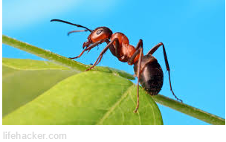
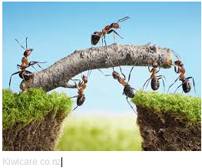
ANT

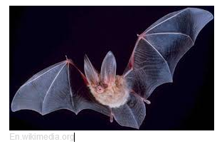
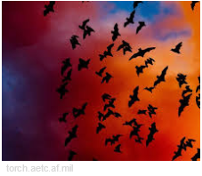
BAT

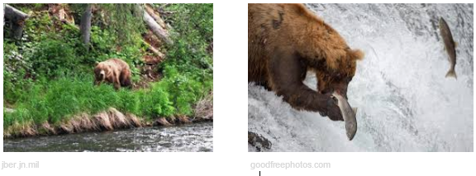
BEAR

BEAVER
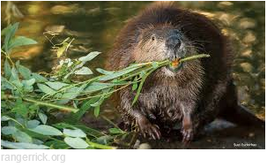
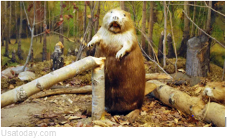

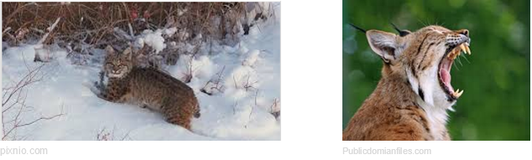
BOBCAT

BUTTERFLY
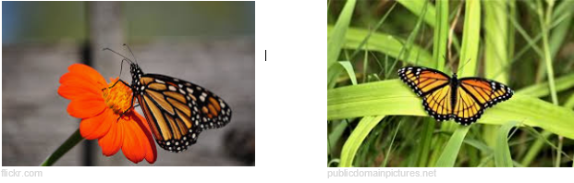

CHIPMUNK
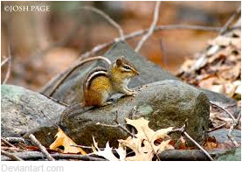
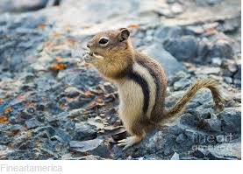

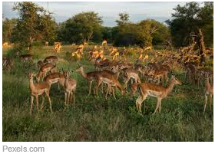
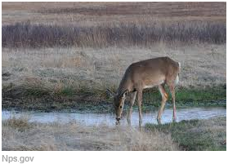
DEER

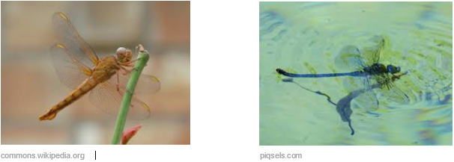
DRAGONFLY
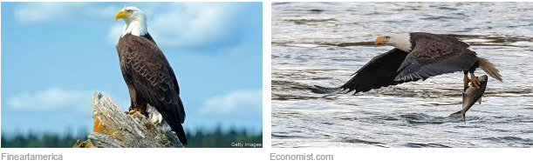
EAGLE

FISH
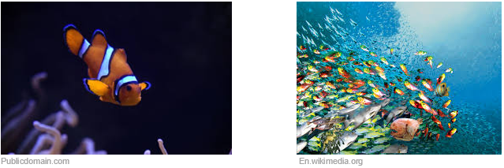

FOX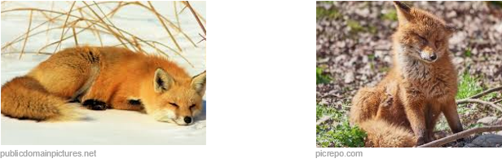

FROG

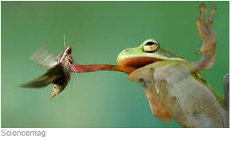
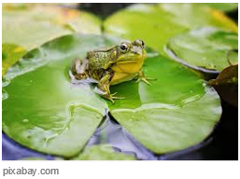

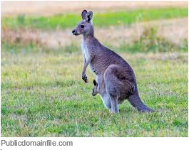
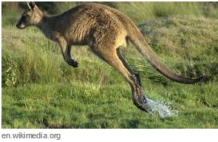
KANGAROO

KOALA

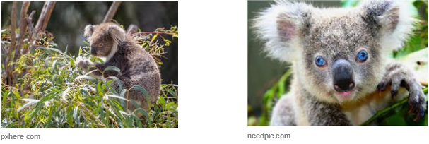

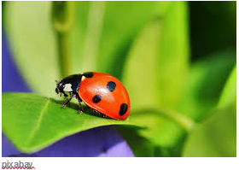
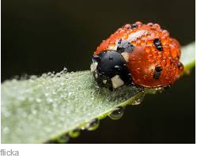
LADYBUG

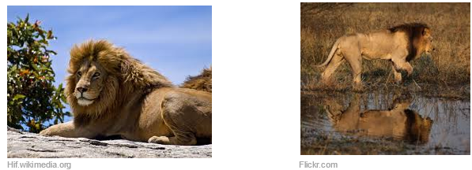
LION

MONKEY
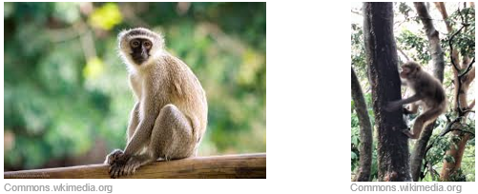
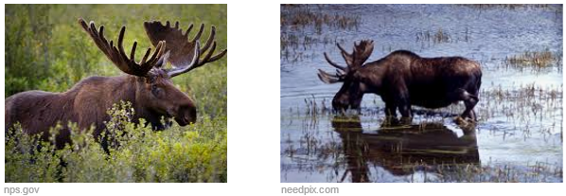
MOOSE

MOUSE

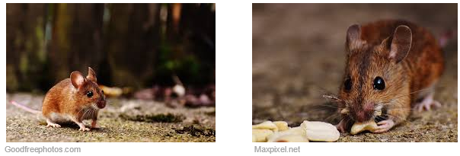

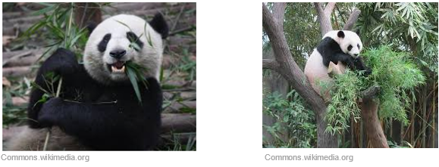
PANDA

RACCOON
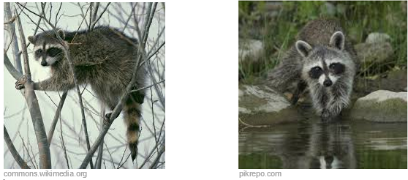

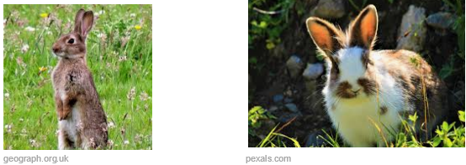
RABBIT

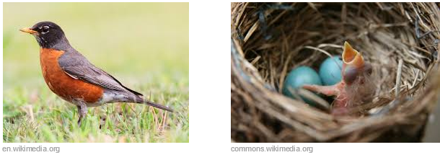
ROBIN

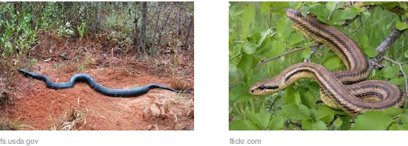
SNAKE

SQUIRREL
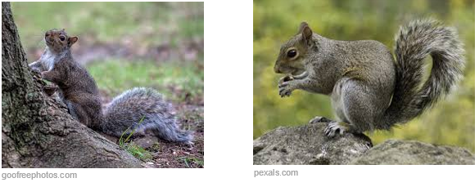
TIGER
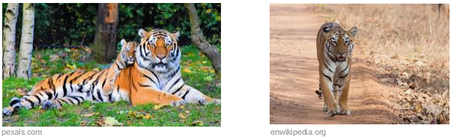

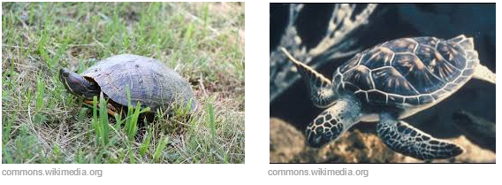
TURTLE

WHALE

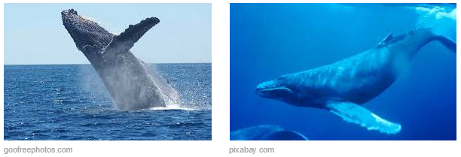

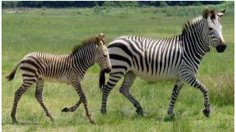
ZEBRA
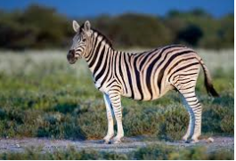

pixabay en.wipipedia.com

