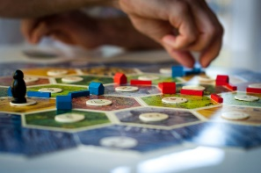
Links to Articles on Benefits of Board Games

The Board Game Guide. 7Amazing Benefits of Playing Board Games With Your Kids, 2019.
Dewar, G. Board Games for Kids: Can They Teach Critical Thinking? Parenting Science, 2012.
Top 10 Health Benefits of Board Games, Health Fitness Revolution, 2020.
Klayman, C. The Benefits of Board Games. Manhattan Psychology Group, PC, Retrieved, 2020.
Marjanen, P et al. Peer Group Learning During the Board Game Sessions. Proceedings of the European Conference on Games Based Learning, 2011.
Young, S. The Benefits of Playing Board Games with Children: What Board Games Teach Kids That Screens and Video Games Can't, Consumer Affairs, 2016.
Zander, M. The Surprising Benefits Your Kids Get From Playing Board Games, Scholastic Magazine, 2019.

